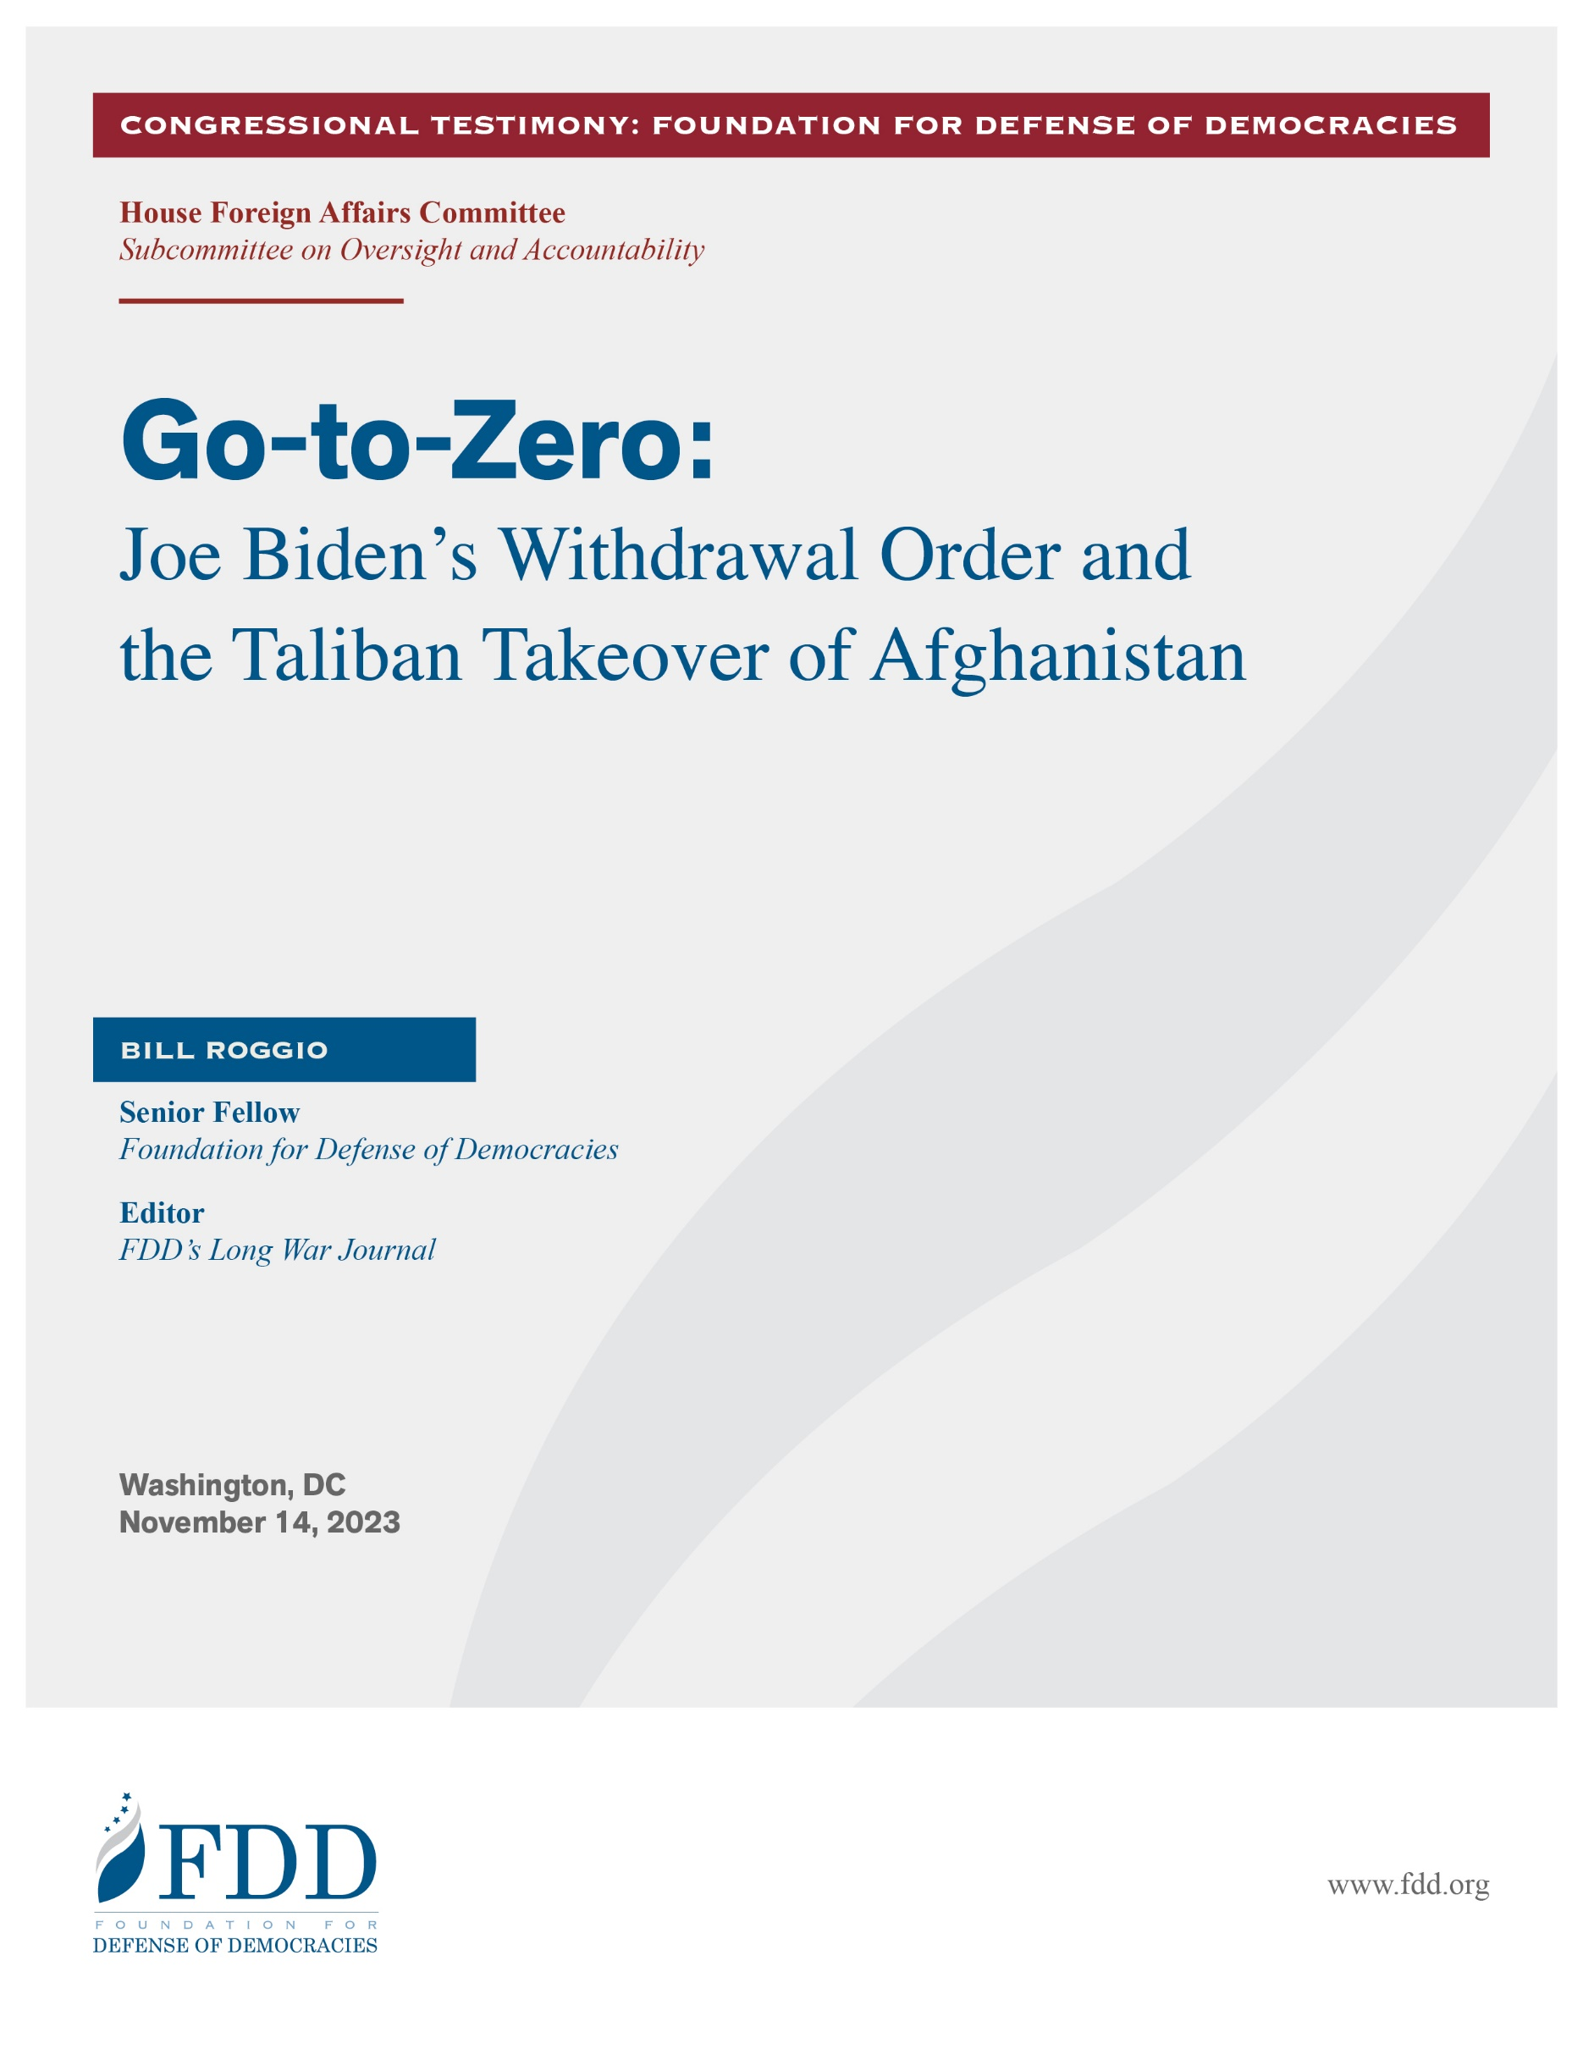
Chairman Mast, Ranking Member Crow, and other members of the committee, thank you for inviting me to testify today concerning the Biden administration’s order to withdraw U.S. forces from Afghanistan and the resulting Taliban takeover of the country.

The Biden administration’s precipitous order to withdraw all U.S. troops from Afghanistan, which was issued less than two months after President Biden entered office, was directly responsible for the collapse of the Afghan government and military and the Taliban’s immediate takeover of Afghanistan. U.S. forces completed the withdrawal just four and a half months after the order was given, giving the Afghan government and military no time to reorganize to fight the Taliban alone. Once the withdrawal order was given, the U.S. military, which played a critical role in keeping the Taliban at bay, focused exclusively on winding down its operations and safely getting its troops and assets out of country.

The impact of the withdrawal order was easy to predict for those who closely watched the situation in Afghanistan. When President Biden issued the order on April 14, 2021, I predicted the Afghan government would collapse by the end of the summer. The Taliban marched into Kabul on August 15, 2021, and Panjshir, the last bastion of resistance to the Taliban, fell by September 7, 2021. The Biden administration clearly did not understand the precarious security situation. If it did understand, it willfully abandoned Afghanistan to the Taliban and its terrorist allies, including al-Qaeda. This resulted in a clear catastrophe for the people of Afghanistan. As I will explain, it was also a catastrophe for U.S. national security. Al-Qaeda today has a stronger position in Afghanistan than it did on September 10, 2001.

Rather than examine its own record candidly, the Biden administration has laid the blame for Afghanistan’s collapse almost solely on the Trump administration’s February 2020 agreement with the Taliban, known as the Doha Agreement. “President Biden’s choices for how to execute a withdrawal from Afghanistan were severely constrained by conditions created by his predecessor,” according to a review led by the Biden administration’s National Security Council. While the Doha Agreement was certainly disastrous and set some conditions for failure within the Afghan military, the Biden administration was under no obligation whatsoever to execute the deal, which President Biden himself described as a bad one.

As with many policy decisions in Washington, the Biden administration sought to justify its action by presenting Americans with a false dichotomy: stay in Afghanistan indefinitely or leave immediately. Other options, such as a phased withdrawal that allowed the Afghan government and military to prepare themselves to fight the Taliban alone, were never considered.

The consequences of the withdrawal are far-reaching and have put U.S. national security at risk.

The Afghanistan of November 14, 2023, is far worse than the Afghanistan of September 10, 2001, the day before al-Qaeda launched its deadly attack on America, which was plotted from Afghan soil. On September 10, 2001, the Taliban did not fully control the country, was mired in a fight for territory with the Northern Alliance, and was isolated internationally. Today, the Taliban is in full control of Afghanistan, has the resources of a state and a military armed with billions of dollars in U.S. weapons that were left behind, and is sending envoys to countries such as China, Russia, and Iran.

Today, Afghanistan is a safe haven for terrorist groups that are hostile to the United States. A June 1, 2023, report by the United Nations Analytical Support and Sanctions Monitoring Team assessed that “the relationship between the Taliban and Al Qaeda remained close and symbiotic, with Al Qaeda viewing Taliban-administered Afghanistan a safe haven,” while al-Qaeda provides support to the Taliban regime. Al-Qaeda is operating training camps in six of Afghanistan’s 34 provinces as well as safe houses and a media operations center. Al-Qaeda is training suicide bombers for the Movement of the Taliban in Pakistan, which attempted to detonate a car bomb in Times Square in May 2010. Al-Qaeda leaders hold leadership positions within the Taliban’s government. The Taliban is issuing passports and national ID Cards to members of al-Qaeda as well as al-Qaeda family members. The Haqqani Network, a Taliban subgroup that is listed by the State Department as a Foreign Terrorist Organization and whose key leaders are listed as Specially Designated Global terrorists because of the group’s close ties to al-Qaeda, holds key positions in the Taliban’s government, including deputy emir and the head of the interior ministry, which issues passports and national ID cards.

Let me explain how the Biden administration’s withdrawal order led directly to the outcome of a Taliban-controlled Afghanistan with an al-Qaeda safe haven. Above all, the withdrawal order had an immediate and devastating impact on the Afghan National Defense and Security Forces (ANDSF):

- No time for the Afghan government and military to reorganize. From the moment the U.S. withdrawal was announced, the U.S. military and State Department focused all efforts on safely extricating U.S. personnel from Afghanistan. The withdrawal process was almost immediate, and there was no time or effort to assist the Afghan government and the ANDSF to formulate and execute a new strategy to fight the Taliban without U.S. support. The Afghan government had hard decisions to make, such as whether it should attempt to defend all of Afghanistan or consolidate its forces and defend key ground. The Afghan government and military never had the time or opportunity to plan for the future.
- Mixed messaging: Many Afghan officials never believed the U.S. was leaving. Both before and after the withdrawal was announced, I had numerous conversations with Afghan officials, including advisors to the president, officials at the ministries of defense and interior, members of parliament, and diplomats. They never truly believed the United States was leaving Afghanistan and abandoning the Afghan people to the predations of the Taliban. I warned the officials that withdrawal was inevitable and that they needed to devise a new strategy to battle the Taliban and search for new allies. To a man, the response was a version of this: “I’ve been assured by [members of Congress/State Department officials/Defense Department officials, the CIA, etc.] that the United States would not actually leave.” Senior Afghan officials never had time to process the reality that the United States was leaving, and in some instances, the Afghan officials were given false hope that the United States wasn’t leaving or that the Biden administration would halt or reverse the withdrawal.
- Demoralization of the ANDSF. It is undeniable that the Doha agreement weakened the morale of the ANDSF, which was dependent on U.S. support for its logistics and operations. Negotiations with the Taliban, without the participation of the Afghan government, sent the wrong message to the ANDSF, many of whom were on the front lines against the Taliban. However, the Biden administration had the opportunity to discard the Doha agreement and either recommit to helping the Afghan government or prepare it for the time when the United States would no longer be there. The withdrawal order was the final nail in the coffin for the ANDSF. Many Afghan outposts besieged by the Taliban were given an ultimatum: surrender or abandon your outposts or fight to the death. Enough Afghan units surrendered or abandoned their posts to give the Taliban a military advantage.
- The end of key U.S. military support. U.S. air support and special operations forces aided Afghan forces if the Taliban penetrated too deeply into key areas, such as when the Taliban took control of Farah, Ghazni, and Kunduz cities between 2016 and 2018. Additionally, U.S. forces helped Afghan special operations units such as the Commandos hunt key Taliban leaders and operatives as well as target Taliban and al-Qaeda facilities, including training camps, bases, weapons, and ammunition depots. Without U.S. support, the Afghan military was limited in its ability to conduct offensive operations, which was a key component in keeping the Taliban at bay.
- ANDSF was dependent on Western tactics and logistics. The United States and NATO built an Afghan military that was dependent on Western tactics and logistics. For instance, the Afghan Commandos were built as an analog to U.S. special operations forces. The Afghan Commandos were dependent on helicopters for transportation, warplanes for close air support, and aircraft for intelligence, surveillance, and reconnaissance. Additionally, ANDSF units in remote locations, sometimes in locations that were besieged by the Taliban, were dependent on air transport for resupply and medical evacuation. Keeping these aircraft in operation requires a sophisticated logistics chain and complicated maintenance, which was provided by both the U.S. military and, more importantly, civilian contractors. Once the withdrawal was announced and bases began to close, the logistics and maintenance activities were severely impacted. Civilian contractors were forced to shut down their operations inside Afghanistan, as they could not operate without the assurances of U.S. and NATO security. There were attempts to remotely provide instructions for maintenance and repairs, but these efforts fell far short of what was needed to keep the Afghan air forces up to full capacity. The withdrawal of U.S. air assets combined with the reduction in availability of Afghan aircraft negatively impacted the ANDSF’s ability to take the fight to the Taliban as well as defend against Taliban onslaughts.
- Mixed messaging and false hope of U.S. military support. The U.S. military, as part of its obligations to the Taliban in the Doha agreement, halted all offensive operations, including airstrikes that kept the Taliban from overrunning important population centers. Yet as the Taliban military advance continued into the summer of 2021, the U.S. military, in an effort to prevent the collapse of Afghan forces, occasionally weighed in with airstrikes. This was most conspicuous in July and early August of 2021, when the Taliban surrounded and prepared to overrun the provincial capitals of Kandahar and Helmand. These interventions gave Afghan government officials and military personnel false hope that the United States would ultimately come to their defense. When the strikes ended, the ANDSF realized they were on their own.
- Blindness to the Taliban’s strategy. After the U.S. “surge” in Afghanistan ended in 2013 and the United States and NATO transferred primary security responsibility to the ANDSF in 2014, the Afghan/NATO strategy of protecting the population centers while ignoring the rural districts was announced. The Taliban embraced the Afghan/NATO strategy and implemented its rural insurgency strategy — it would take control of rural districts and spread its influence into neighboring districts with the ultimate goal of reaching the population centers. The Taliban patiently implemented its strategy, slowly gaining control or contesting districts over time. Typically, the Taliban gained control or contested 1-3 percent of Afghanistan’s 407 districts per quarter, with the exception being between November 2017 to December 2018, when the Taliban lost control of districts due to the Trump administration’s efforts to beat back the Taliban’s advances. Once the Trump administration opened negotiations with the Taliban, the Taliban resumed its slow but steady march to take control or contest districts. By April 13, 2021, the day before President Biden announced the withdrawal, the Taliban controlled 77 districts and contested 194 others, according to an ongoing assessment of the status of Afghanistan’s districts by FDD’s Long War Journal. While the situation was dire, the ANDSF, with the support of the U.S. military, was still battling the Taliban for control of territory, and the Taliban did not control any key population centers. The withdrawal announcement allowed the Taliban to implement the final phase of its strategy: seize control of key districts, then provincial centers, and finally march on Kabul. Without U.S. support, the ANDSF was unable to withstand the Taliban offensive. By June 23, the Taliban controlled 139 districts and contested 173. By Aug. 6, the Taliban controlled 223 districts and contested 116. That same day, the Taliban seized control of its first province, Nimruz, when it overran the provincial capital. The remaining provinces, with the exception of Panjshir, fell by August 15, when the Taliban entered the capital of Kabul. The Taliban had a military strategy to take over Afghanistan and implemented it with near precision. It needed U.S. forces to leave the country to succeed, and the Biden administration obliged.

Debunking several myths about the withdrawal from Afghanistan.

To defend its decision to withdraw from Afghanistan, the Biden administration has perpetrated some myths, which must be addressed as they relate to the catastrophic decision to abandon our erstwhile Afghan allies.

- The Afghan military wouldn’t fight. Days after the Taliban marched into Kabul, President Biden said that “The Afghan military collapsed, sometimes without trying to fight.” The statement is an insult to the tens of thousands of Afghans who served in the ANDSF and fought the Taliban for two decades. An estimated 66,000 ANDSF personnel died fighting the Taliban since the United States overthrew the Taliban regime in late 2001. Hundreds of thousands more likely were wounded. The ANDSF fought the Taliban, at times imperfectly. But they fought and died to defend their country.
- Afghanistan collapsed “in 11 days.” After the Taliban took control of Afghanistan, Chairman of the Joint Chiefs of Staff General Mark Milley said, “There was nothing that I or anyone else saw that indicated a collapse of this army, and this government, in 11 days.” But as I explained in point number 7 above, the collapse of the Afghan government didn’t occur in 11 days. It was 11 days from when the first province, Nimruz, fell under Taliban control until Kabul, the capital, collapsed. The 11 days were merely the endgame of the Taliban strategy to take control of Afghanistan. General Milley and others within the military and intelligence establishment watched the Taliban’s advance throughout the summer of 2021 and yet maintain that the collapse of the Afghan government was a surprise, something that no one could have foreseen. Nothing could be further from the truth.
- The Taliban was a partner in peace and is a reliable counterterrorism partner. The Trump administration’s misguided Doha agreement made the critical error of treating the Taliban as a reliable partner in peace. As part of the agreement, the Taliban promised it would not shelter members of al-Qaeda and agreed to enter negotiations with the Afghan government. The Doha Agreement was defunct the moment it was signed, as the Taliban continued to shelter leaders of al-Qaeda and other terror groups. Additionally, the Taliban never entered negotiations with the Afghan government. Despite the Taliban reneging on the terms of the Doha Agreement, the Biden administration treated it as sacrosanct and ordered the withdrawal. Despite the Taliban’s numerous violations of the Doha Agreement, thus proving its unreliability, the Biden administration entrusted the Taliban with providing security at Hamid Karzai International Airport during the final evacuation. This misguided notion that the Taliban could be trusted is responsible for the deaths of 13 American servicemen in an Islamic State suicide attack. Since the withdrawal, the Biden administration has held up the Taliban as a reliable counterterrorism partner. Yet al-Qaeda remains ensconced in Afghanistan.
- Al-Qaeda has been defeated. For well over a decade, U.S. intelligence, military, and government officials as well as analysts have triumphantly claimed that al-Qaeda has been decimated, defeated, degraded, diminished, or destroyed or has declined or is dead. President Biden said the following on June 30, 2023: “Remember what I said about Afghanistan? I said Al Qaeda would not be there. I said it wouldn’t be there. I said we’d get help from the Taliban. What’s happening now? What’s going on? Read your press. I was right.” President Biden is anything but right. As I noted in the introduction, al-Qaeda isn’t only alive, it is thriving in its safe haven of Afghanistan with training camps, safe houses, and media operations center and leaders serving in the Taliban’s government. Al-Qaeda was so comfortable with the Taliban’s victory that its last leader, Ayman al Zawahiri, sheltered in a safe house in Kabul that was run by the Haqqani Network. The United States killed Zawahiri in a drone strike on his safe house in Kabul on July 31, 2022, just two weeks short of the one-year anniversary of the Taliban takeover of Afghanistan. No other strikes targeting al-Qaeda leaders in Afghanistan have been executed. The Biden administration would have you believe that Zawahiri was the last important al-Qaeda leader in Afghanistan. However, other key al-Qaeda leaders are known to be sheltering in Afghanistan. It is rumored that Zawahiri’s successor, Saif al Adel as well as his deputy Abdal-Rahman al-Maghrebi are rumored to have traveled to Afghanistan from Iran and may be sheltering there to this day.

The disaster that befell Afghanistan was predictable and predicted. The Biden administration refused to give the Afghan government and military the time it needed to adapt to fighting on its own. The situation grew dire as the deadline for the U.S. withdrawal approached, but the administration and the leaders of the U.S. military ignored the warning signs. The result? The Taliban dominates Afghanistan, and al-Qaeda is in a stronger position than it was on September 10, 2001.

Thank you.

https://www.pbs.org/newshour/politics/u-s-review-of-chaotic-afghanistan-withdrawal-blames-trump
https://d3i6fh83elv35t.cloudfront.net/static/2023/04/US-Withdrawal-from-Afghanistan.pdf
https://www.longwarjournal.org/archives/2023/08/two-years-after-u-s-withdrawal-the-taliban-enjoys-an-iron-fisted-grip-on-afghanistan.php
https://www.longwarjournal.org/wp-content/uploads/2023/06/UN-Sanctions-Monitoring-report-Afghanistan-14th.pdf
https://www.longwarjournal.org/archives/2023/06/al-qaeda-actively-operating-training-camps-in-5-afghan-provinces.php
https://www.longwarjournal.org/archives/2023/06/afghan-taliban-and-al-qaeda-aiding-pakistani-talibans-insurgency.php
https://www.longwarjournal.org/archives/2023/06/al-qaeda-leaders-are-prominently-serving-in-taliban-government.php
https://www.longwarjournal.org/archives/2021/09/talibans-government-includes-designated-terrorists-ex-guantanamo-detainees.php
https://www.longwarjournal.org/mapping-taliban-control-in-afghanistan
https://www.longwarjournal.org/archives/2021/08/taliban-takes-full-control-of-nimruz-province-seizes-capital.php
https://www.cbsnews.com/news/11-days-in-august-how-afghanistan-fell/
https://obamawhitehouse.archives.gov/administration/cabinet/exit-memos/department-state
https://www.brookings.edu/articles/al-qaida-today-18-years-after-9-11
https://www.whitehouse.gov/briefing-room/speeches-remarks/2021/08/16/remarks-by-president-biden-on-afghanistan
https://thesoufancenter.org/research/diminished-but-not-defeated-the-evolution-of-al-qaeda-since-september-11-2001
https://twitter.com/billroggio/status/1650470449376051201
https://twitter.com/billroggio/status/1651631787611701250
https://www.theatlantic.com/international/archive/2012/05/how-strong-is-al-qaeda-today-really/256609
https://www.longwarjournal.org/archives/2023/07/fact-check-president-bidens-claim-al-qaeda-is-not-in-afghanistan-is-demonstrably-false.php
https://www.longwarjournal.org/archives/2022/08/u-s-kills-al-qaeda-emir-ayman-al-zawahiri-in-drone-strike.php
https://www.longwarjournal.org/archives/2023/09/u-s-officials-continue-to-downplay-al-qaedas-presence-in-afghanistan.php
https://www.longwarjournal.org/archives/2023/09/u-s-officials-continue-to-downplay-al-qaedas-presence-in-afghanistan.php

